**Chapter 2 (Physical Layer)**

**Physical Layer**

One of the major functions of the physical layer is to move data in the form of electromagnetic signals across a transmission medium. Generally, the data usable to a person or application are not in a form that can be transmitted over a network. For example, a photograph must first be changed to a form that the transmission media can accept. Transmission media work by conducting signals along a physical path.

**NOTE:** To be transmitted, data must be transformed to signals.

**Analog and Digital data**

Data can be analog or digital.

Analog data: Data that is continuous.

Example: Analog data, such as the sounds made by a human voice, take on continuous values.

When someone speaks, an analog wave is created in the air.

Digital data: Data that takes on discrete values.

Example: Data that is stored in computer memory in the form of Os and 1s.

**Analog and Digital Signals**

Like the data they represent, signals can be either analog or digital.

Analog signal: An analog signal has infinitely many levels of intensity over a period of time. As the wave moves from value Ato value B,it passes through and includes an infinite number of values long its path.

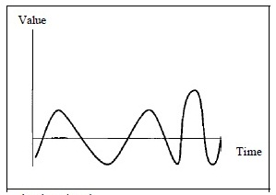

Figure 1: Analog Signal

Digital signal: A digital signal can have only a limited number of defined values. Although each value can be any number, it is often as simple as 1 and O.

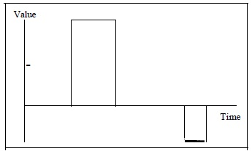

Figure 2: Digital signal

**NOTE**: In Figure 1 and 2,vertical axis represents the value or strength of a signal. The horizontal axis represents time.

**Periodic and Non-periodic Signals**

Both analog and digital signals can take one of two forms: periodic or non-periodic.

Periodic signal: A periodic signal completes a pattern within a measurable time frame, called a period, and repeats that pattern over subsequent identical periods. The completion of one full pattern is called a cycle.

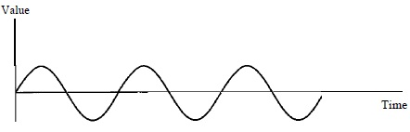

T

T

Figure 3: Periodic analog signal

Figure 3: illustrates a periodic analog signal. T represents a period.

Non-periodic signal: A non-periodic signal changes without exhibiting a pattern or cycle that repeats over time.

Figure 1 depicts a non-periodic analog signal.

Both analog and digital signals can be periodic or non-periodic. In data communications, we commonly use periodic analog signals because they need less bandwidth and non-periodic digital signals because they can represent variation in data.

**Periodic Analog Signals**

Periodic analog signals can be classified as simple or composite. A simple periodic analog signal, called a sine wave, cannot be decomposed into simpler signals. A composite periodic analog signal is composed of multiple sine waves.

**Sine Wave**



Figure 4: Sine wave

* The sine wave is the most fundamental form of a periodic analog signal.
* A sine wave can be represented by three parameters: the peak amplitude, the frequency and the phase. These three parameters fully describe a sine wave.

Peak Amplitude: The peak amplitude of a signal is the maximum absolute value. For electric signals, peak amplitude is normally measured in volts.

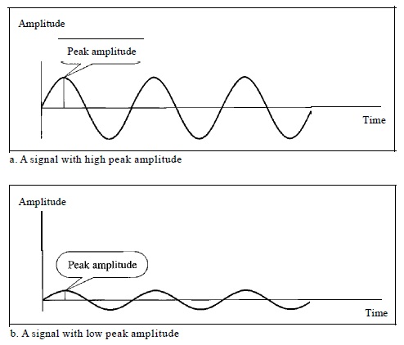

Figure 5: Peak amplitude

Period: Period refers to the amount of time, in seconds, a signal needs to complete 1 cycle. It is expressed in seconds.

Frequency: Frequency refers to the number of cycles a signal completes in 1 second. It is measured in hertz.

**Relationship between Period and Frequency**

If ‘f’ represents frequency and ‘T’ represents period, then

$$f=\frac{1}{T}$$

and

$$T=\frac{1}{F}$$

**NOTE:** Frequency and period are the inverse of each other. Frequency can also be referred to the number of periods in 1s.

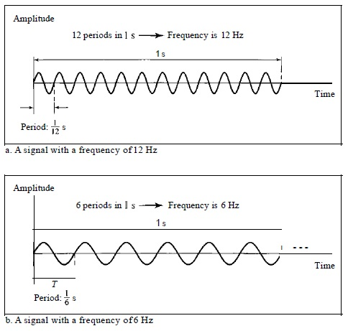

Figure 6: Two signals with same amplitude but different frequencies.

Phase: Phase describes the position of the waveform relative to time 0 (Zero). If a wave can be thought of as something that can be shifted backward or forward along the time axis, phase describes the amount of that shift.

Phase is measured in degrees or radians.

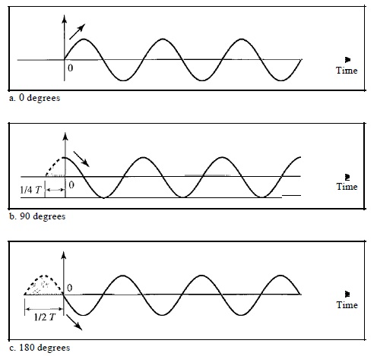

Figure 7: Three sine waves with the same amplitude and frequency, but different phases

1. 0 degrees

* A sine wave with a phase of 0° starts at time 0 with a zero amplitude. The amplitude is increasing, or
* A sine wave with a phase of 0° is not shifted.

1. 90 degrees

* A sine wave with a phase of 90° starts at time 0 with a peak amplitude. The amplitude is decreasing, or
* A sine wave with a phase of 90° is shifted to the left by 1/4 cycle.

1. 180 degrees

* A sine wave with a phase of 180° starts at time 0 with a zero amplitude. The amplitude is decreasing.
* A sine wave with a phase of 180° is shifted to the left by 1/2 cycle.

Wavelength

1st interpretation:

The distance between peaks (high points) of a signal is called wavelength.

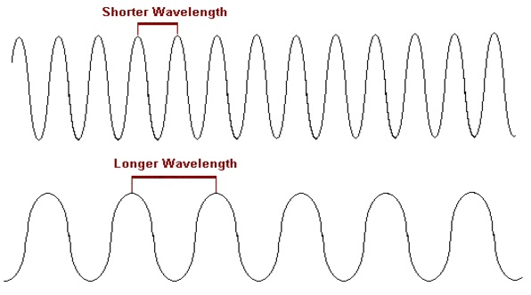

Figure 8: Wavelength of a signal

2nd interpretation:

The wavelength is the distance a simple signal can travel in one period.

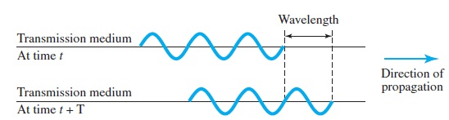

Figure 9: Wavelength and period of a signal

**NOTE:** While the frequency of a signal is independent of the medium, the wavelength depends on both the frequency and the medium

Wavelength is often used to describe the transmission of light in an optical fiber. If the propagation speed is known, the wavelength can be calculated as follows:-

wavelengtheqn.jpg

**Time and Frequency Domains**

**NOTE:** An analog signal is defined by its amplitude, frequency and phase. All the previous representations of analog signals in this lecture note were time-domain plots.

**Time Domain**

* The time-domain plot shows changes in signal amplitude with respect to time (it is an amplitude-versus-time plot).
* Phase is not explicitly shown on a time-domain plot.

**Frequency Domain**

* A frequency-domain plot shows the relationship between the amplitude and frequency of a signal.
* A frequency-domain plot is concerned with only the peak value and the frequency.
* Changes of amplitude during one period are not shown.

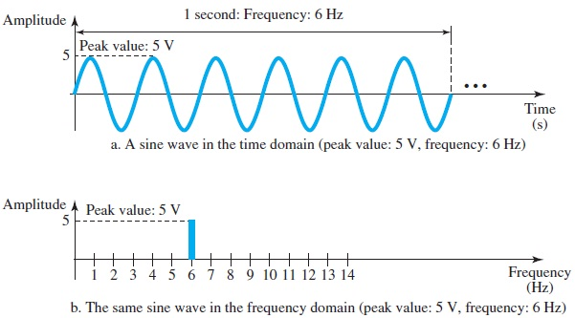

Figure 10: The time-domain and frequency-domain plots of a sine wave

**NOTE:** A complete sine wave in the time domain can be represented by one single spike in the frequency domain.

**Composite Signals**

Simple sine waves have many applications in daily life:-

* A power company sends a single sine wave with a frequency of 60 Hz to distribute electric energy to houses and businesses.
* A single sine wave can be used to send an alarm to a security center when a burglar enters a bank.

However, if only a single sine wave was used to convey a conversation over the phone, it would make no sense and carry no information. Only a buzz would be heard.

**NOTE:** A single-frequency sine wave is not useful in data communications, a composite signal; a signal made of many simple sine waves is required.

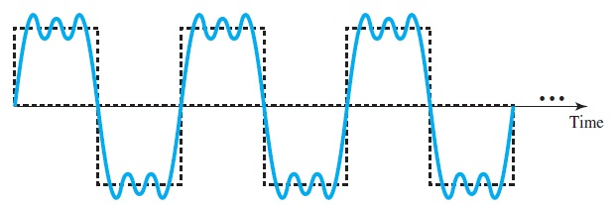

Figure 11: A composite signal

**Example:**

The following figure shows a non-periodic composite signal in both the time domain and the frequency domain.

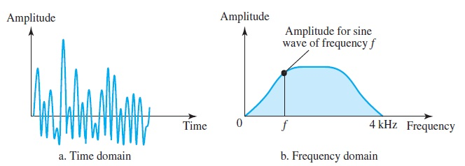

Figure 12: Time and frequency domain of a non-periodic analog signal

Figure 12 shows a non periodic composite signal. It can be a signal created by a microphone or a telephone set when a word or two is pronounced. In this case, the composite signal cannot be periodic; because that implies that the same word or words with exactly the same tone are being repeated. In a time-domain representation of this composite signal, there are an infinite number of simple sine frequencies.

The frequency decomposition of the signal yields a continuous curve. There are an infinite number of frequencies between 0 and 4kHz. To find the amplitude related to frequency *f*, a vertical line is drawn at *f* to intersect the curve. The height of the vertical line is the amplitude of the corresponding frequency.

**Bandwidth**

* The range of frequencies contained in a composite signal is its bandwidth, or
* The bandwidth of a composite signal is the difference between the highest and the lowest frequencies contained in that signal.

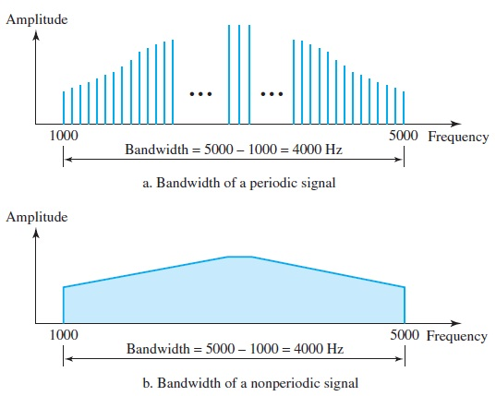

Figure 13: The bandwidth of periodic and non-periodic composite signals

**Digital Signals**

Data can also be represented by a digital signal. For example, a 1 can be encoded as a positive voltage and a 0 as zero voltage.

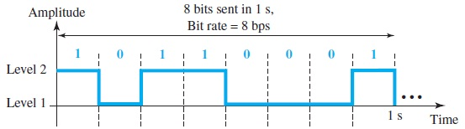

Figure 14: A digital signal with two levels

A digital signal can have more than two levels. In this case, we can send more than 1 bit for each level.

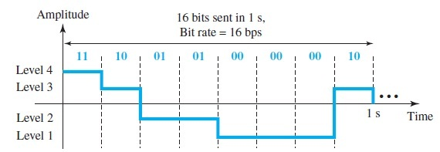

Figure 15: A digital signal with four levels

**Bit rate:**

The bit rate is the number of bits sent in 1s, expressed in bits per second (bps).

**Bit length:**

The bit length is the distance one bit occupies on the transmission medium.

**NOTE:** A digital signal is a composite analog signal with an infinite bandwidth (frequencies between zero and infinity). Periodic digital signals are rare in data communication. We mostly have non periodic digital signals.

**Transmission of digital signals**

Considering a non-periodic digital signal, a digital signal can be transmitted by using two approaches:-

1. Baseband transmission
2. Broadband transmission

**Baseband transmission**

Baseband transmission means sending a digital signal over a channel without changing the digital signal to an analog signal.

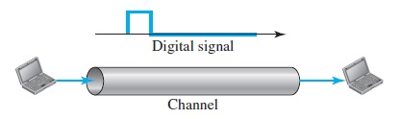

Figure 16: Baseband transmission

* Baseband transmission requires a low-pass channel, a channel with a bandwidth that starts from zero.
* A low pass channel can be had in the following cases:-
  + If there is a dedicated connection between a sender and a receiver.
  + If devices are connected to a bus but only devices are allowed to communicate at an instance of time.

**NOTE**: A low pass channel with an infinite bandwidth is ideal but is impossible to have.

There can be two kinds of low pass channels:-

1. Low pass channel with a wide bandwidth

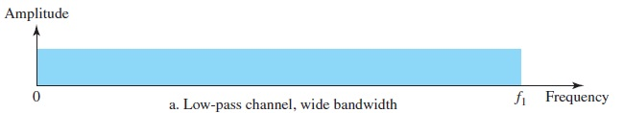

1. Low pass channel with a narrow bandwidth

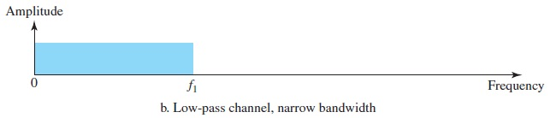

**Transmission using a low pass channel with a wide bandwidth**

* If the exact form of a non-periodic digital signal is to be preserved with vertical segments vertical and horizontal segments horizontal, the entire range of frequencies between zero and infinity needs to be send across a medium.
* This is possible if a dedicated medium with an infinite bandwidth between the sender and receiver is available, which preserves the exact amplitude of each component of the composite signal (Remember, a digital signal is a composite analog signal with an infinite bandwidth).
* However a channel with an infinite bandwidth is not possible. Fortunately, the amplitudes of the frequencies at the border of the bandwidth are so small that they can be ignored.
* Therefore, a medium such as a coaxial or fiber optic cable, which has a very wide bandwidth, can be effectively used to transmit digital signals with good accuracy.

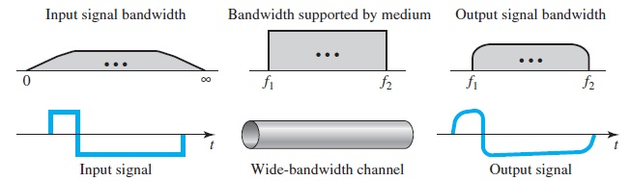

Figure 17: Baseband transmission using a dedicated medium

Note that *f*1 is close to zero, and *f*2 is very high.

* Although the output signal is not an exact replica of the original signal, the data can still be deduced from the received signal. Note that although some of the frequencies are blocked by the medium, they are not critical.